2022 Year 7 Science – Classifications – ICT Week 3 Task

Name:
Date:
Class Number:

ICT Aim: discover the meaning of vertebrates and invertebrates.

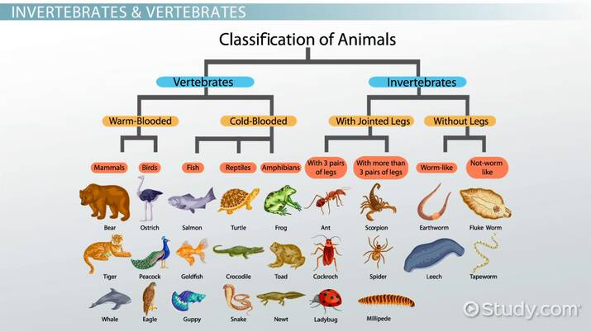

Let’s Begin!
Use the internet to help search the answers to these questions below:
INTRODUCTION QUESTIONS

Question: Define the animal kingdom; which belongs to 1 of the 5 kingdoms within the classification hierarchy.
Answer:

Question: What are scientists called that studies animals?
Answer:

CHARACTERISTICS OF ANIMALS QUESTIONS

Question: What does ‘multicellular’ mean and list an animal under this category
Answer:

Question: What does ‘unicellular’ mean? and list an animal under this category
Answer:

Question: What does ‘heterotroph’ mean? and list an animal under this category
Answer:

Question: What does ‘autotroph’ mean? and list an animal under this category
Answer:

Question: What does ‘motile’ mean? and list an animal under this category
Answer:

Question: What does ‘non-motile’ mean? and list an animal under this category
Answer:

Question: What are ‘eukaryotic’ cells? List an animals that is considered ‘eukaryotic’ organisms?
Answer:

Question: What are ‘prokaryotic’ cells? List an animals that is considered ‘prokaryotic’ organisms?
Answer:

IDENTIFYING THE PHYLUMS OF ANIMALIA

Question: Define ‘Poriferans’ and list an animal under this category
Answer:

Question: Define ‘Platyhelminthes’ and list an animal under this category
Answer:

Question: Define ‘Annelids’ and list an animal under this category
Answer:

Question: Define ‘Cnidarians’ and list an animal under this category
Answer:

Question: Define ‘Nematodes’ and list an animal under this category
Answer:

Question: Define ‘Molluscs’ and list an animal under this category
Answer:

Question: Define ‘Arthropods’ and list an animal under this category
Answer:

Question: Define ‘Echinoderms’ and list an animal under this category
Answer:

Question: Define ‘Chordates’ and list an animal under this category
Answer:

VERTEBRATES VS INVERTEBRATES

Question: Define ‘vertebrates’ and provide 3 examples of vertebrate animals
Answer:

Question: Define ‘invertebrates’ and provide 3 examples of invertebrate animals
Answer:

EDUCATIONAL GAMES

Task: Play the Dino Park Game
Click the link to access the game:
https://www.ecosystemforkids.com/games/2nd-grade/vertebrates-and-invertebrates/activity.html

Task: Play the Vertebrate vs Invertebrate Game
Click the link to access the game:
https://www.tinytap.com/activities/g1fca/play/vertebrates-and-invertebrates

Task: Play the Vertebrate vs Invertebrate Game
Click the link to access the game:
https://wordwall.net/resource/7317278/science/y2-vertebrate-or-invertebrate

Task: Play the Vertebrate vs Invertebrate Game
Click the link to access the game:
https://wordwall.net/resource/1479301/vertebrate-and-invertebrate-animals

Task: Play the Vertebrate vs Invertebrate Game
Click the link to access the game:
https://wordwall.net/resource/2177091/invertebrates-and-vertebrates/vertebrate-and-invertebrates

Task: Play the Classifications Game
Click the link to access the game:
https://www.ecosystemforkids.com/games/2nd-grade/classify-mammals-fish-amphibian/activity.html

RECAP PREVIOUS WEEKS THEORY

Task: Play the War Game
Click the link to access the game:
https://www.ecosystemforkids.com/games/2nd-grade/living-and-nonliving-things/activity.html

